Insert school logo here.

School Name Here 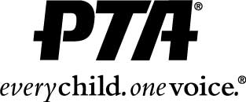

School Here PTA
Connect with your Child’s School & Community

We invite you to join School PTA for 2018-2019!

Annual membership $Dues Amount per adult - cash only

PTA Sponsored projects:
- Teacher Appreciation,
- Parent Volunteers,
- Parent Education,
- Reflections Art Program and more.

Registration Information
Full Name:
 | Last |  |  |  | First |  | M.I.
Phone:
Email
Child Name
Grade: |  | Teacher :
Child Name
Grade: |  | Teacher :

Would you like to volunteer?

Total Amount Paid - CASH ONLY: $__________

